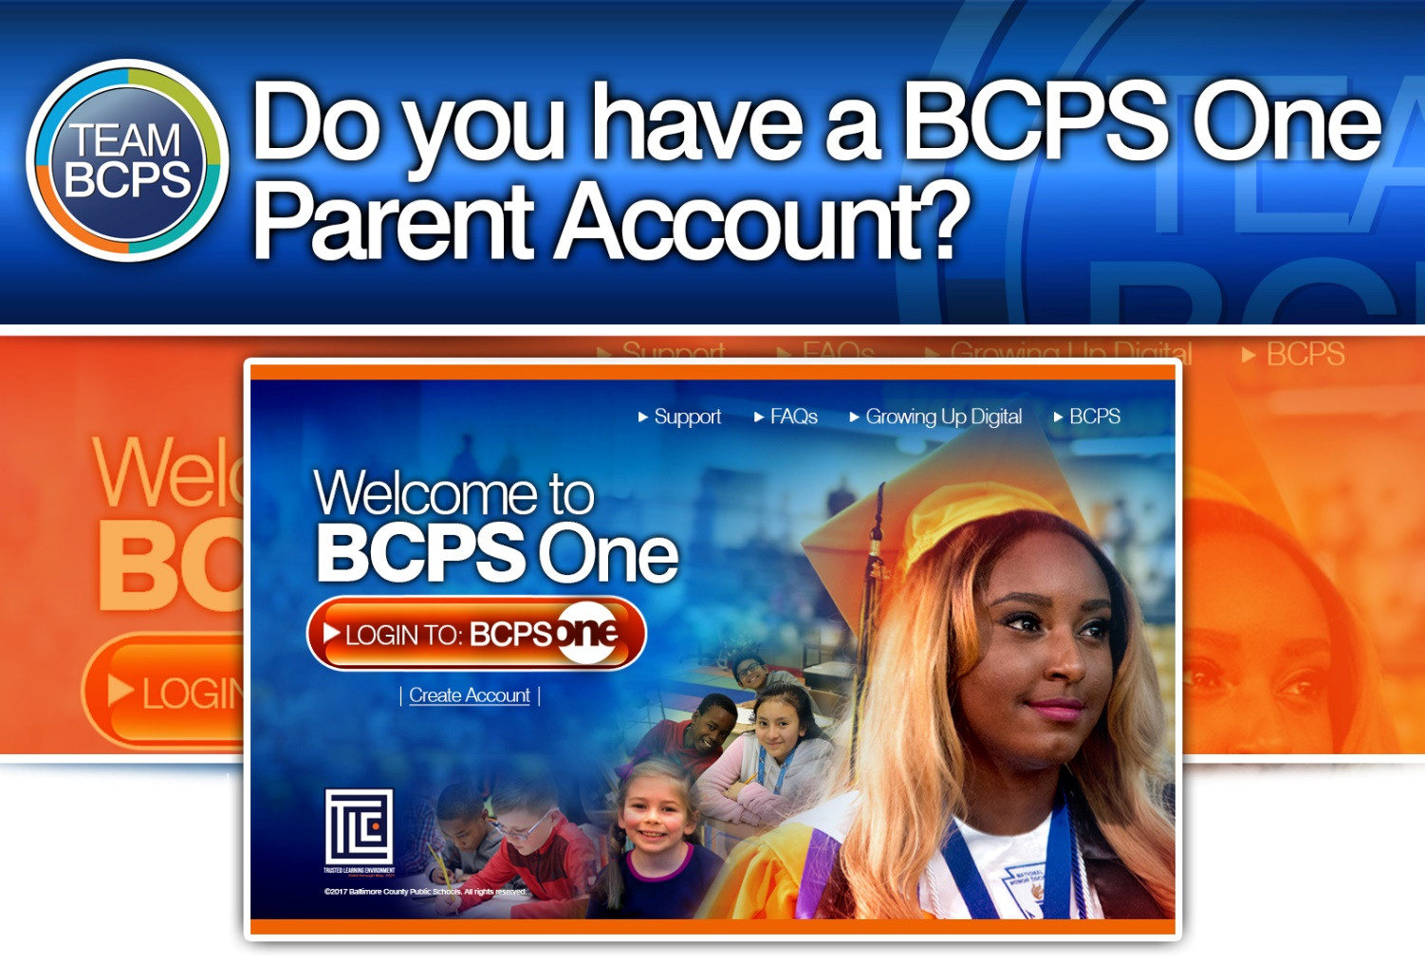
With a BCPS One Parent Account, parents can:
See student schedules in Student Info
Pay for school lunches in MySchoolBucks
View assignments and grades in Schoology
Read report cards in Student Info
Access student attendance in Student Info
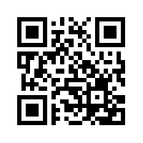
Create a BCPS One Account
Stay Involved in Your Student’s Education!
BCPS One is Baltimore County Public Schools’ online parent portal. Parents/guardians* are encouraged to sign up for a BCPS One account to view student grades, assignments, attendance information, report cards, and instructional content.
Part 1: Complete the steps below to create a BCPS One Account
- Go to https://bcpsone.bcps.org and click “Create Account.”
- Complete the form and then click the “Create” button.
- Important: Check your e-mail for the BCPS One Account Activation Code.
Note: If the BCPS One account activation screen is no longer visible, click the link in the email to open the activation screen again.
- Enter your e-mail address and the account activation code on the BCPS One account activation screen.
- Click the “Activate Account” button.
- Login to your activated BCPS One account and proceed to Part 2 (below).
Part 2: Add Students to Your Account
- Log in to your BCPS One account and navigate to My Profile. (Users who already have an account, but need to add another student would start here.)
- Click “Add a Student.” You will be prompted to select your student’s school from the drop-down menu and to enter the student’s birthdate.
Note: If you have twins with the same birth date the account will link to both students.
Reminder: If the parent/guardian e-mail address, first name, and last name on file with the school does not match the email address you used to create your BCPS One account, your student will not be successfully added to your account.
- Click Submit.
Note: If BCPS One still lists you as a Community Member, log out and then log in again in order to see the updates reflected in the account.
*Only users identified in the BCPS One Student Information System (SIS) as a contact authorized to make educational decisions or view-only access for the student will be allowed access to their student’s information in BCPS One. An email address, first name, and last name must be on file with the school and associated with each student in order to make educational decisions or view student information.

